Temperature, humidity and buzzer alarm Code

**Introduction**

we want to use the temperature and humidity sensor to obtain the ambient temperature in real time, and the buzzer will sound an alarm when the temperature is higher than 20°C; below 20°C, the buzzer will not sound an alarm. (Temperature setting is for testing only, exact temperature can be changed). The following are the codes and connecting pictures.

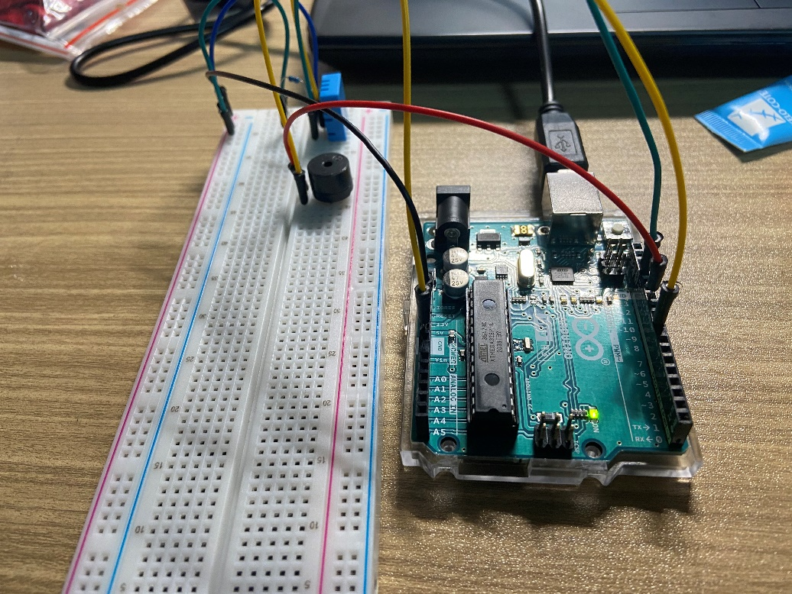

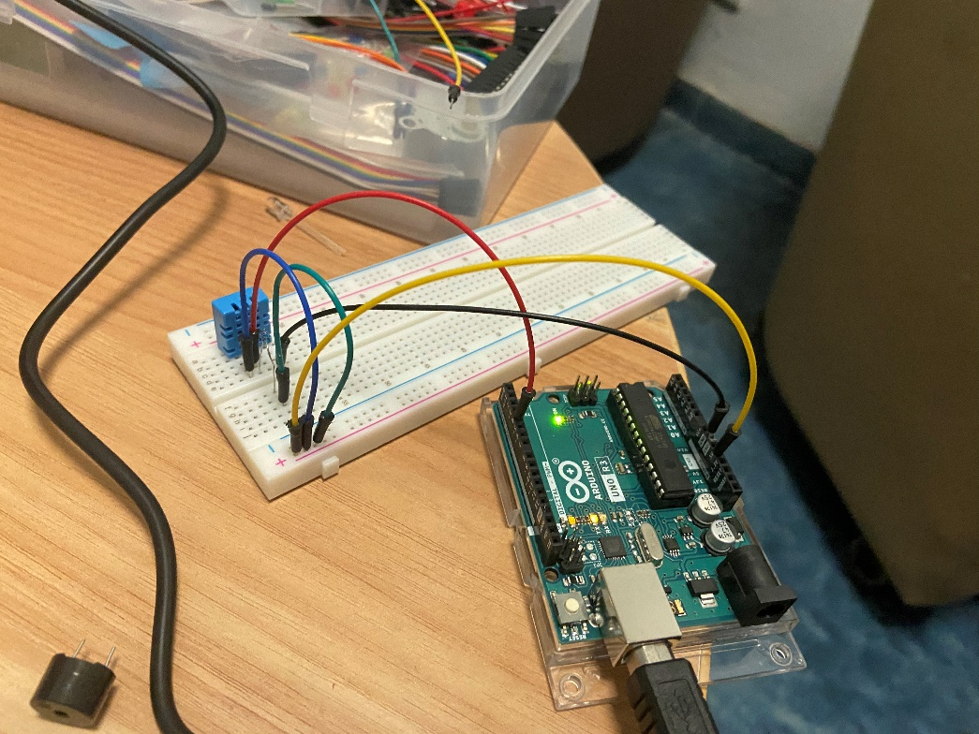

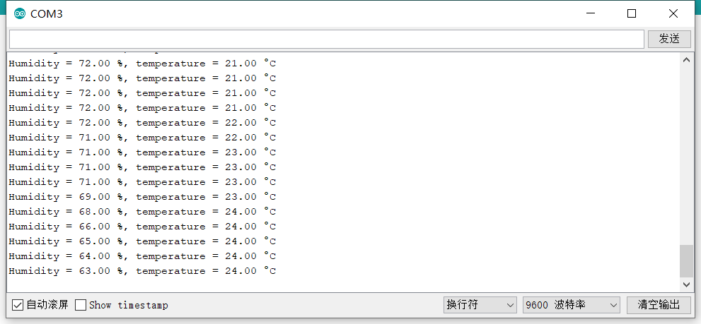

* 1. Code

#include <dht.h>

#define buzzer 11

dht mydht11;

int dhtpin = 8;

float humidity;

float temperature;

void setup(){

pinMode(buzzer,OUTPUT);

Serial.begin(9600);

}

void warning(){

for(int i=0;i<=100;i++){

digitalWrite(buzzer,HIGH);

delay(2);

digitalWrite(buzzer,LOW);

delay(1);

}

}

void loop() {

mydht11.read11(dhtpin);

humidity=mydht11.humidity;

temperature=mydht11.temperature;

Serial.print(String("") + "Humidity = "+ humidity + " %");

Serial.println(String("")+", temperature = "+ temperature +" °C");

if(temperature>20){

warning();

}

delay(2000);

}